## **Lab_Day-1 ANP-C9180 (Introduction to Python)**

Download Python:

Visit the official Python website at <https://www.python.org/downloads/> and download the latest Python installer for Windows. Choose the version that matches your system (e.g., 32-bit or 64-bit).

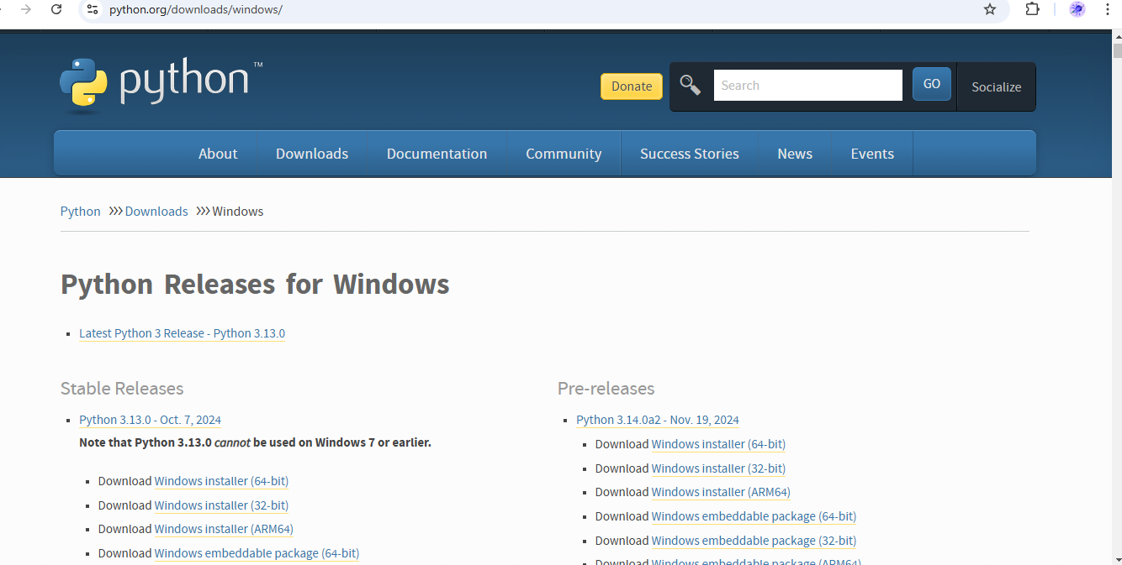

Run the Installer:

Double-click the downloaded installer (e.g., python-3.x.x.exe) to run it. Make sure to check the box that says "Add Python X.X to PATH" during installation. This option is essential for using Python from the command line.

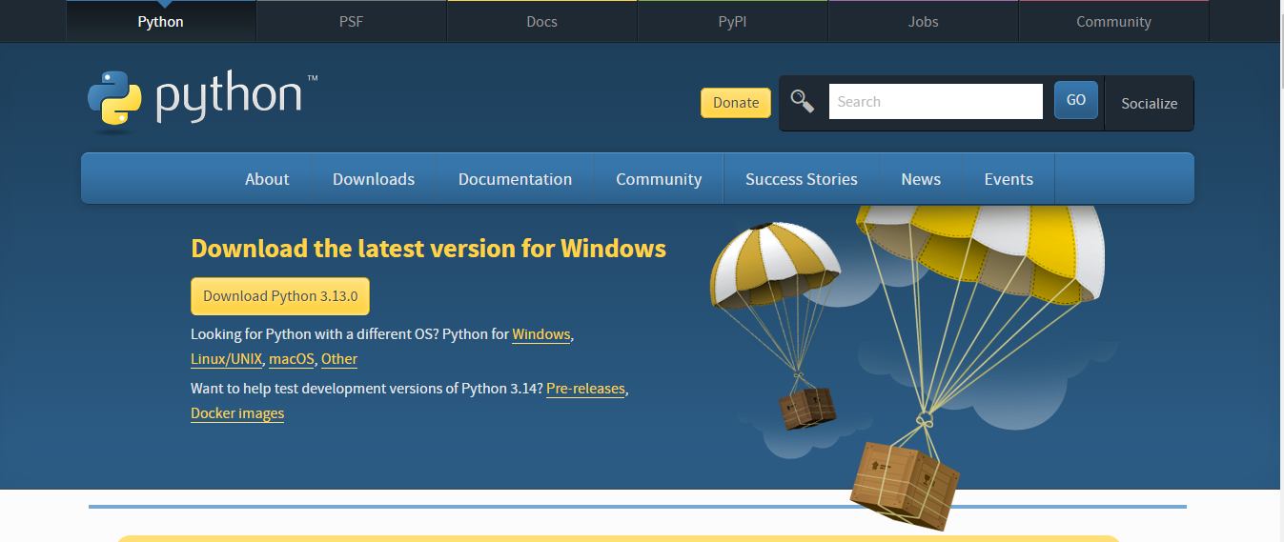

Install Python:

Click "Install Now" to start the installation process. Python will be installed on your system.

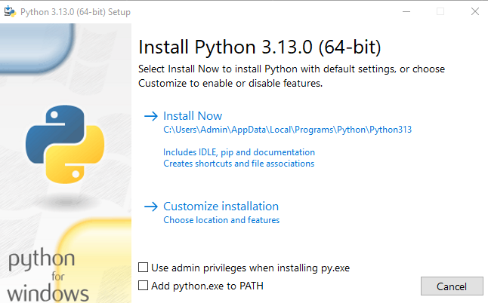

Green Line: Wait patiently for the green line to complete

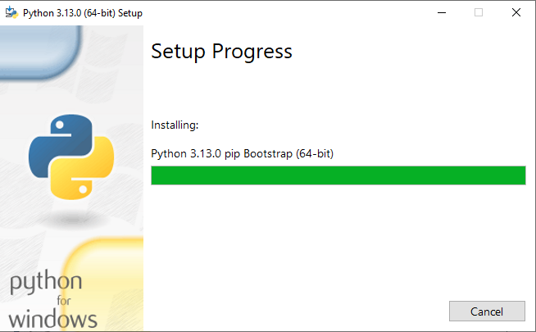

Successful Message:

After Installation, you can receive the successful message

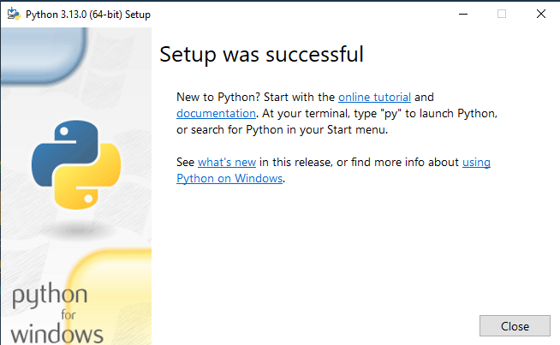

Demonstration of Code

**Print Hello world**

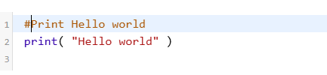

**Output:**



**Defining and accessing local variables**

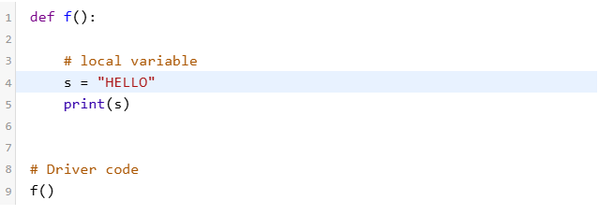

**Output:**



**Create a global variable in Python**

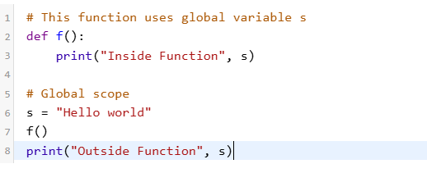

**Output:**



**Write a code that describe Indentation error**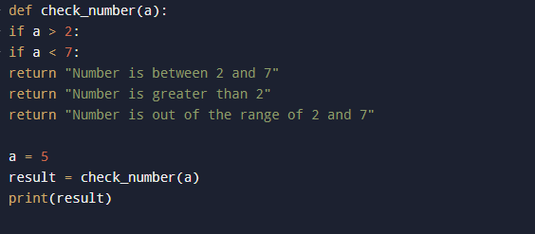

**Output**

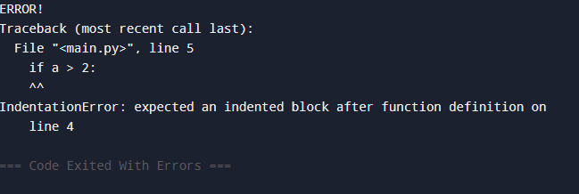

**Write a code for string, int and float input.**

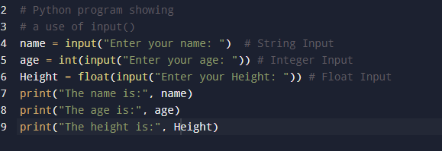

**Output:**

